Frontend System Architecture
The application is a Single Page Application (SPA) built with React 19 and TypeScript, utilizing Vite for the build system. It follows a modular, service-oriented architecture where UI components interact with a centralized service layer to communicate with the backend.

1. High-Level Architecture Diagram
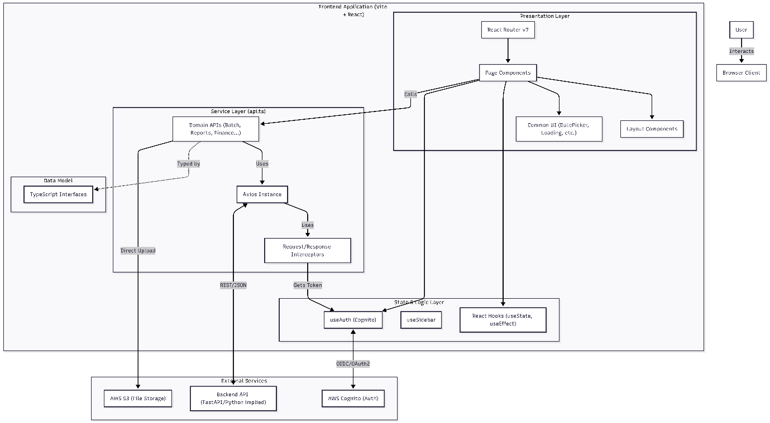

2. Technology Stack
- Core Framework: React v19, TypeScript.
- Build Tool: Vite (Fast HMR and bundling).
- Routing: React Router DOM v7 (Client-side routing).
- UI Framework: React Bootstrap (Bootstrap 5 components), Bootstrap Icons, Lucide React.
- HTTP Client: Axios (API communication).
- Authentication: AWS Cognito via react-oidc-context and oidc-client-ts.
- Data Visualization: Recharts (Charts and Graphs).
- Utilities:
  - date-fns (Date manipulation).
  - exceljs & file-saver (Report exporting).
  - html-to-image (Screenshot/Sharing features).
  - react-toastify (Notifications).

3. Architectural Layers
A. Presentation Layer (Components)
This layer handles the UI and user interaction.
- Layouts: Layout.tsx, Slidebar.tsx, PageHeader.tsx provide the structural shell (Sidebar, Header, Footer).
- Pages: Functional components (e.g., Configurations.tsx, PreviousDayReport.tsx) representing specific routes.
- Common Components: Reusable UI elements like CustomDatePicker, Loading, StyledSelect.
- Forms: Uses controlled components with local state for data entry (e.g., EditBatchSimple.tsx).
B. State Management Layer
The application primarily uses React Hooks rather than a global store like Redux (though Redux is present as a dependency of recharts, the app logic relies on hooks).
- Local State: useState and useEffect manage component-specific data (fetching data on mount, form inputs).
- Context API: Used for global UI state, such as the Sidebar toggle state (SidebarProvider).
- Custom Hooks:
  - useAuth: Wraps OIDC logic to provide user profile, tokens, and login/logout methods.
  - useSidebar: Manages responsive sidebar behavior.
C. Service Layer (src/services/api.ts)
This is the backbone of data communication. It abstracts the HTTP complexity from the UI.
- Axios Instance: Configured with a baseURL (from environment variables) and default headers.
- Interceptors:
  - Request: Automatically injects the Authorization: Bearer <token> and X-Tenant-ID headers.
  - Response: Global error handling (e.g., auto-logout on 401 Unauthorized).
- Domain Modules: The API is organized into specific objects for better maintainability:
  - batchApi, dailyBatchApi (Production data)
  - reportsApi, financialReportsApi (Analytics)
  - inventoryItemApi, purchaseOrderApi, salesOrderApi (ERP features)
  - configApi (System settings)
D. Data Model Layer (src/types)
TypeScript interfaces define the shape of data requests and responses, ensuring type safety across the application.
- Examples: BatchResponse, DailyBatch, OperationalExpense, ApiResponse<T>.

4. Key Workflows
Authentication (AWS Cognito)
- The app uses react-oidc-context to handle the OIDC flow with AWS Cognito.
- Upon successful login, the access_token and custom claims (like custom:organization for Tenant ID) are stored in memory/session.
- useAuth hook exposes this state to components and the API service.
- The API interceptor reads these values to authenticate every backend request.
Data Fetching & Reporting
- Trigger: A component (e.g., PreviousDayReport) mounts or a filter changes.
- Service Call: The component calls a specific function in api.ts (e.g., dailyBatchApi.getSnapshot).
- API Request: Axios sends an HTTP GET request with filters as query parameters.
- Response: The backend returns JSON data.
- Rendering: The component updates its local state (gridData, summaryData) and renders the table/chart.
- Export: Utilities like exceljs or html-to-image process the rendered data for user download.
Financial & Inventory Management
- CRUD Operations: Forms (e.g., CreateOperationalExpenseForm) send POST/PATCH requests via operationalExpenseApi.
- Validation: Basic validation happens in the UI (required fields, positive numbers) before the request is sent.
- Feedback: react-toastify displays success or error messages based on the promise resolution in the component.

